**Day3 Tasks**

1. Calculate average of 5 numbers.

print("Calculate average of 5 numbers.")

print("===========================")

sum=0

for i in range(1,6):

a=int(input())

sum+=a

avg=sum/5

print(avg)

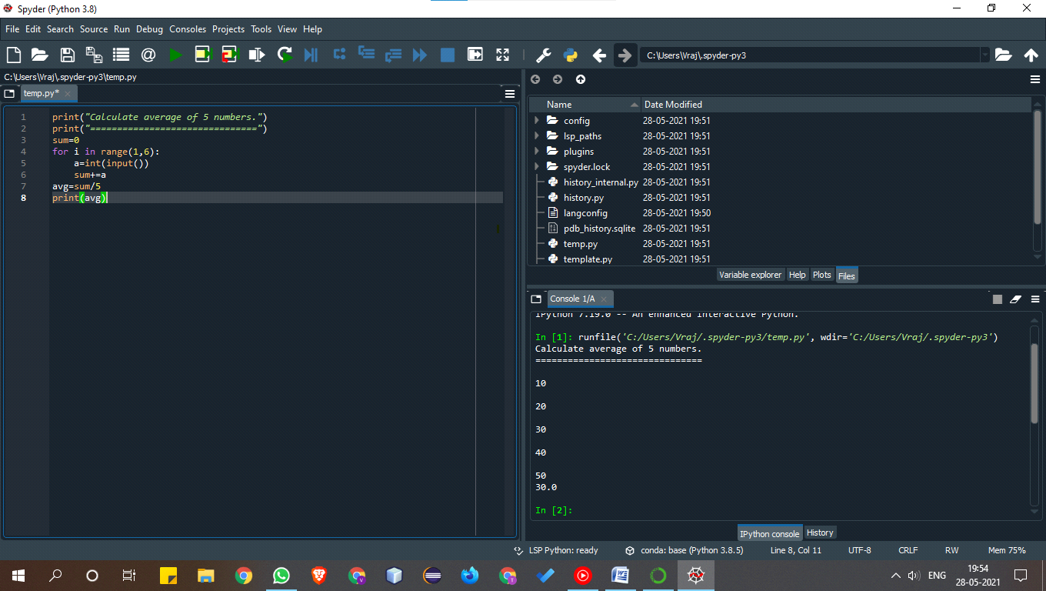

2. Check whether number is even or odd.

print("Check whether number is even or odd.")

print("=================================")

number=int(intput())

if number%2==0:

print(f"{number} is Even")

else:

print(f"{number} is Odd")

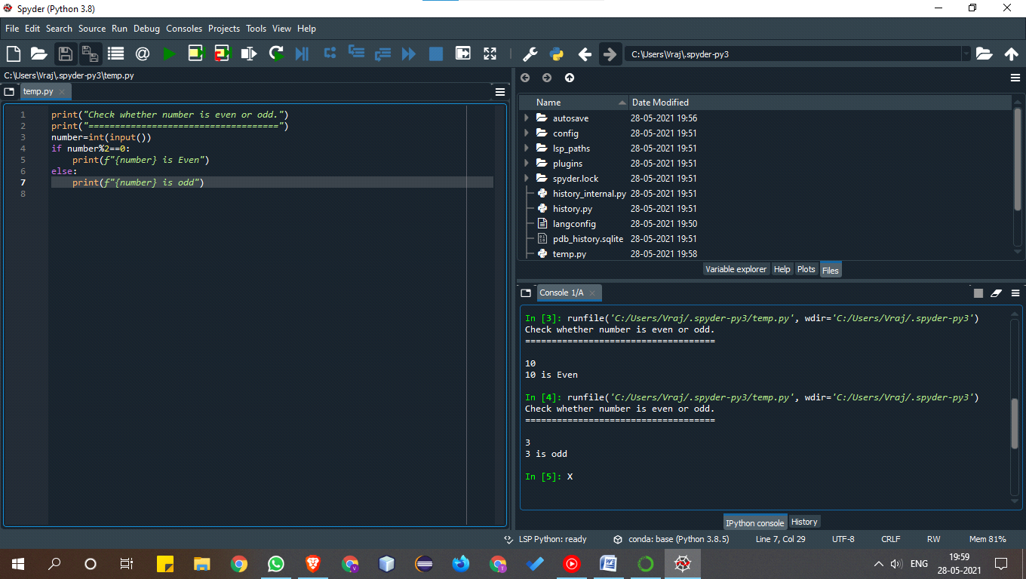

3. Take a year and check whether it is leap year or not

print("Take a year and check whether it is leap year or not")

print("============================================")

year=int(input("Enter the Year"))

if (year % 4)==0:

if (year%100)==0:

if(year%400)==0:

print(f"{year} is a leap year")

else:

print(f"{year} is not a leap year")

else:

print(f"{year} is a leap year")

else:

print(f"{year} is not a leap year")

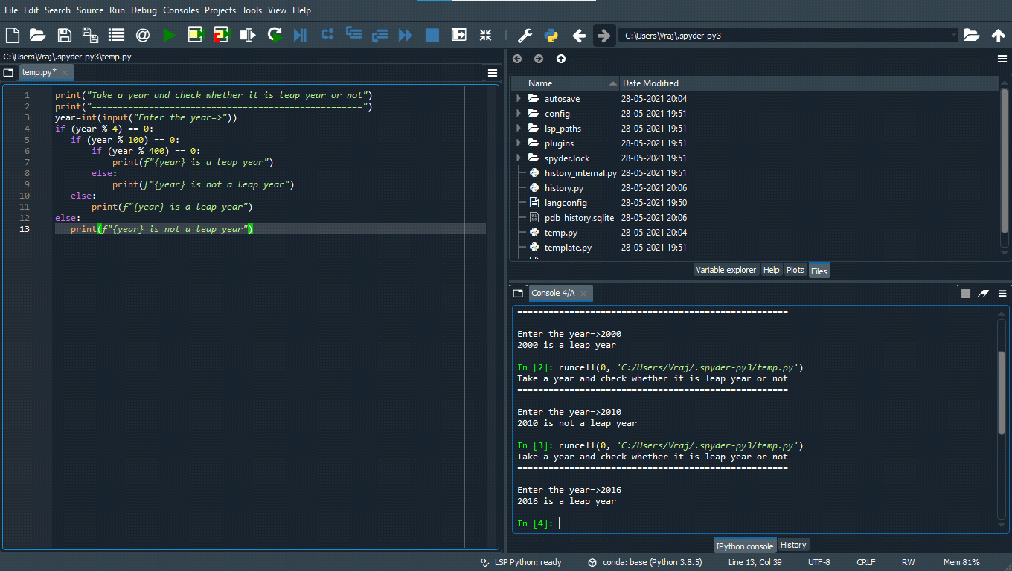

4. Take a number and check whether it is zero, positive or negative.

print("Take a number and check whether it is zero, positive or negative.")

print("=======================================================")

number = int(input())

if number > 0:

print(f"{number} is positive")

elif number < 0:

print(f"{number} is negative")

else:

print(f"{number} is zero")

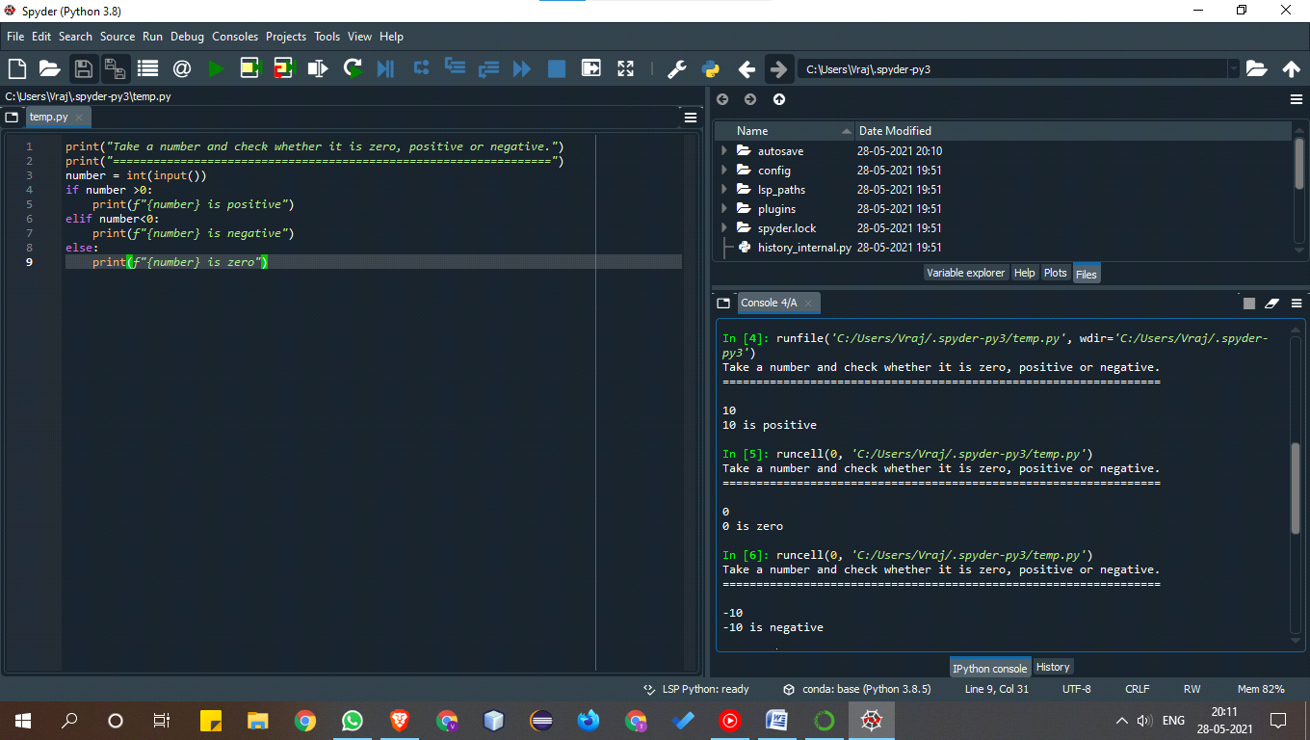

5. Take 2 numbers and display greatest number. (Also check equal number condition)

print("Take 2 numbers and display greatest number. (Also check equal number condition")

print("======================================================")

number1 = int(input())

number2 = int(input())

if number1 > number2:

print(f"{number1} is greater")

elif number2 < number1:

print(f"{number2} is greater")

else:

print(f"Both number are equal")

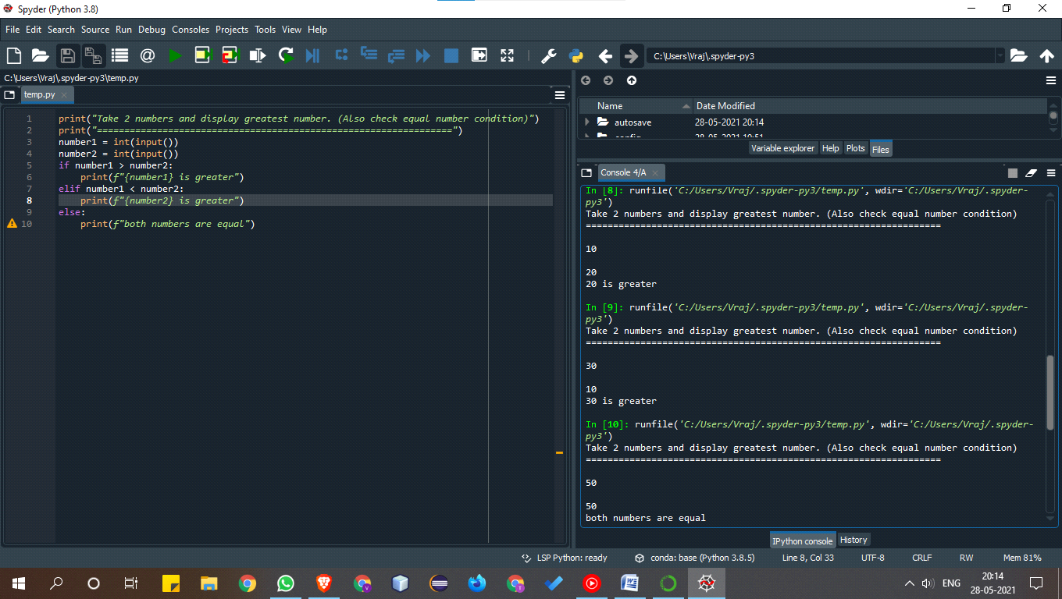

6. Take a number and find factorial of that number.

print("Take a number and find factorial of that number.")

print("=====================================================")

number = int(input())

fact=1

for i in range(1,number+1):

fact*=i

print(fact)

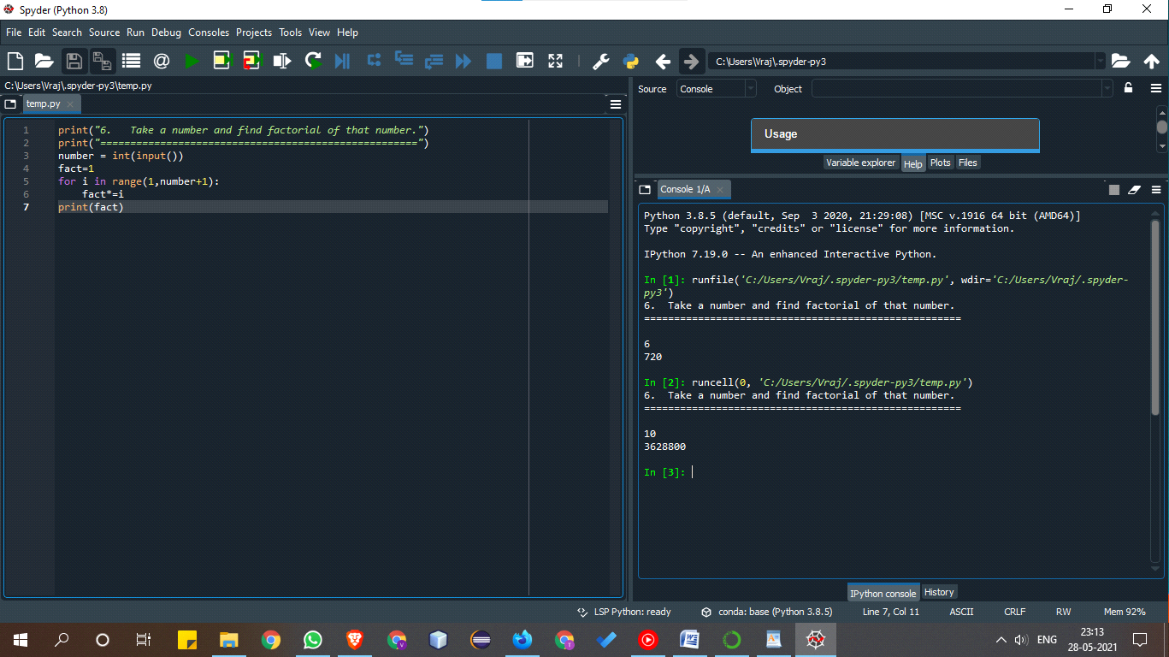

7. Write a program to swap 2 numbers using third variable.

print("Write a program to swap 2 numbers using third variable.")

print("=======================================================")

number1 = int(input())

number2 = int(input())

print("before swaping")

print(f"number1={number1}")

print(f"number2={number2}")

temp=number1

number1=number2

number2=temp

print("After Swaping")

print(f"number1={number1}")

print(f"number2={number2}")

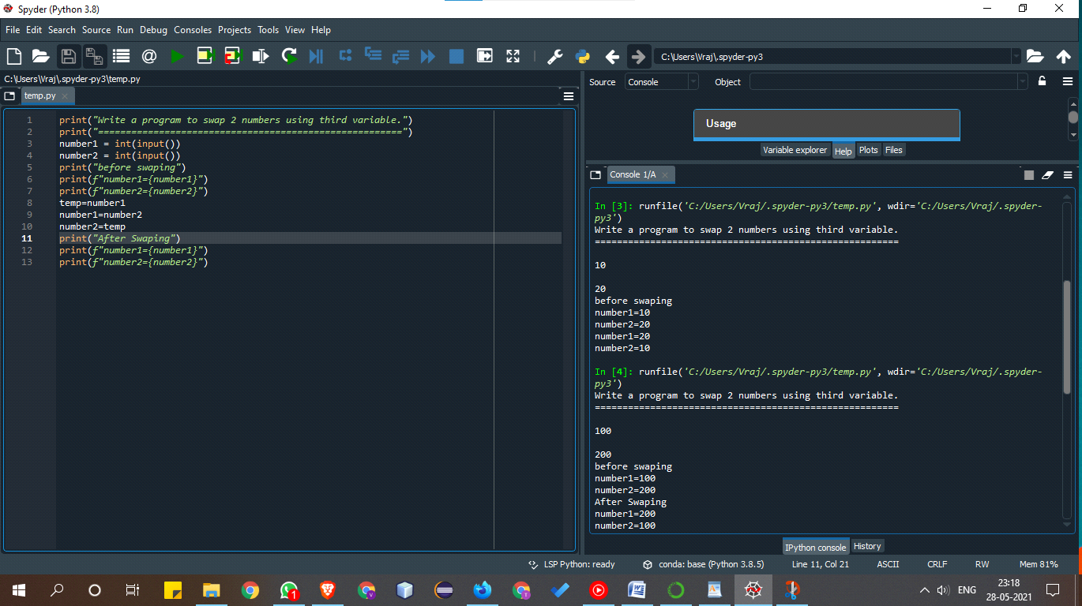

8. Take 2 numbers and find smallest number.

Print(“Take 2 numbers and find smallest number”)

num1 = int(input())

num2=int(input())

if num1>num2:

print(num2,”is smaller”)

elif num2>num1:

print(num1,”is smaller”)

else:

print(“Both are same”)

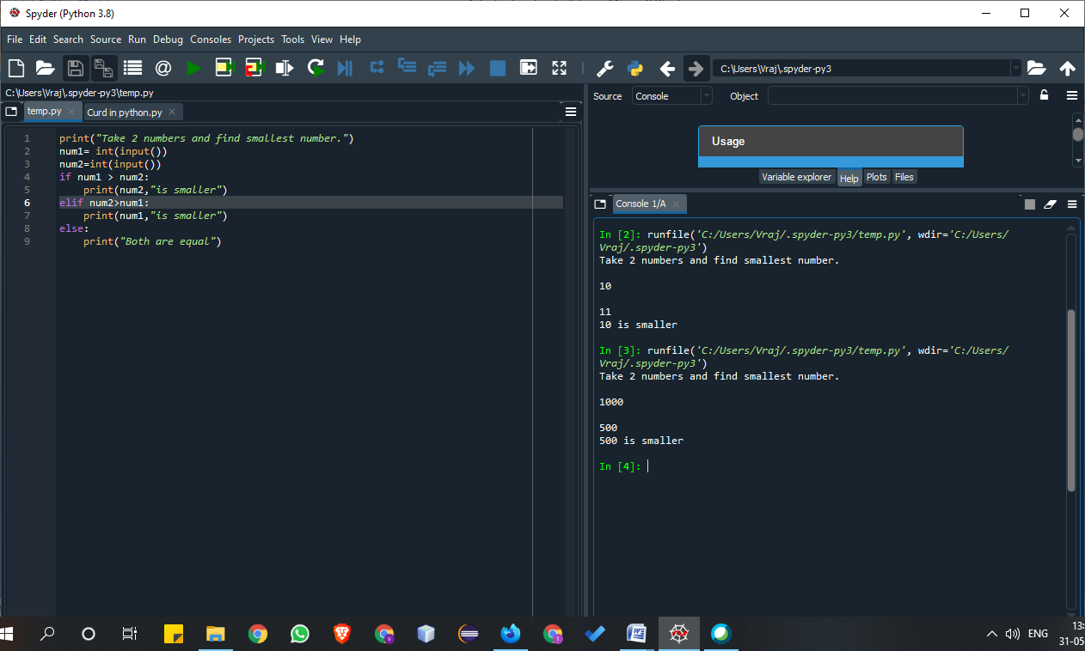

9. Take a number check if a number is less than 100 or not. If it is less than 100 then check if it is odd or even.

print(“Take a number check if a number is less than 100 or not. If it is less than 100 then check if it is odd or even.”)

num=int(input())

if num<100:

if num%2==0:

print(num,”is even”)

else:

print(num,”is odd”)

else:

print(num,”is greater than 100”)

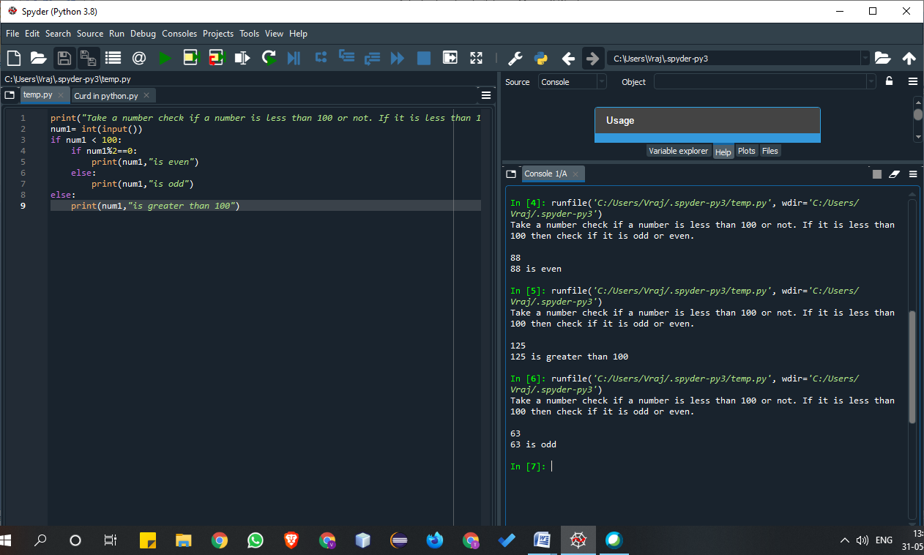

10. Take a number to print the square of a number if it is less than 10.

print(“Take a number to print the square of a number if it is less than 10”)

num=int(input())

if num<10:

print(num*num)

else:

print(num,”is greater than 10”)

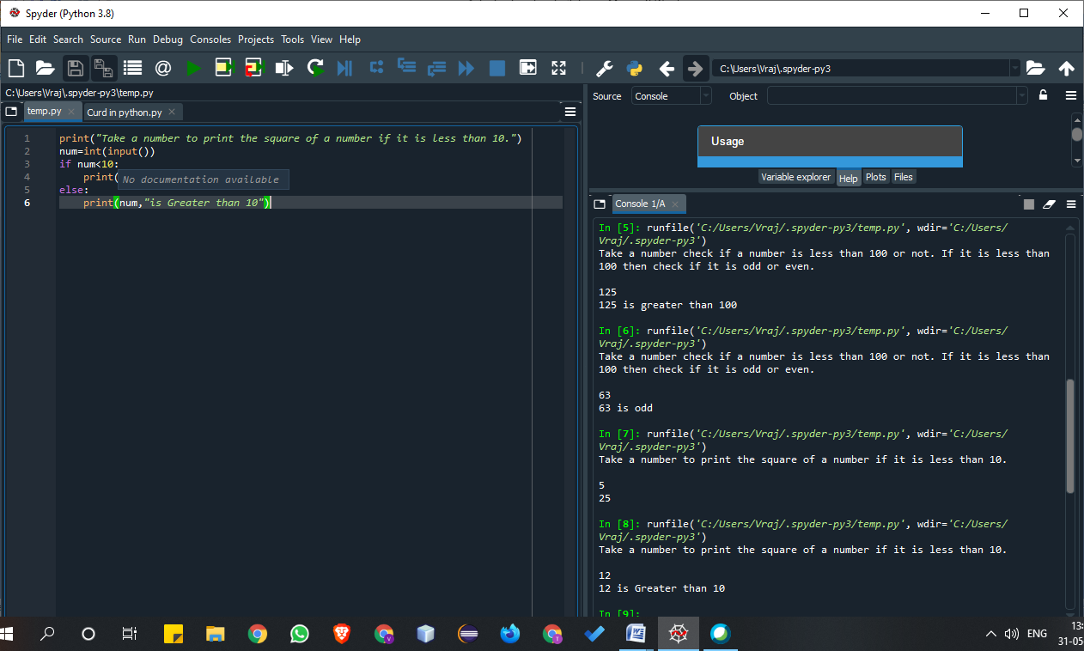

11. Take a number and check whether it is zero, positive or negative using nested IF…ELSE statement .

print(“Take a number and check whether it is zero, positive or negative using nested IF…ELSE statement”)

num=int(input())

if num>0:

print(num,”is a positive”)

elif num<0:

print(num,”is a negative”)

else:

print(num,”is a zero”)

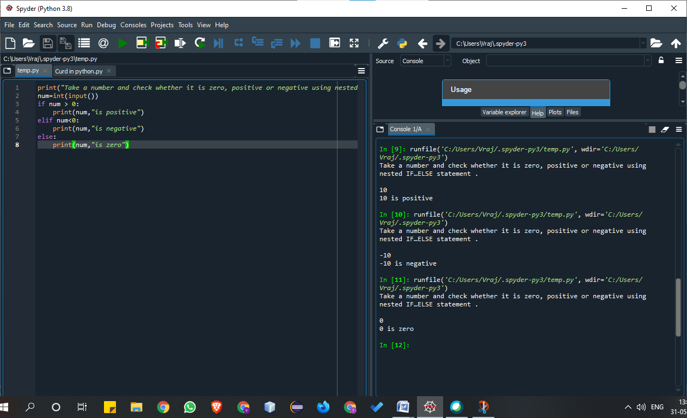

12. Take 3 numbers and find greatest number using nested IF….ELSE statement.

print(“Take 3 numbers and find greatest number using nested IF…ELSE statement”)

num=int(input())

num1=int(input())

num2=int(input())

if num>num1:

if num>num2:

print(num,”is greater”)

else:

print(num2,”is greater”)

else:

if num1>num2:

print(num1,”is greater”)

else:

print(num2,”is greater”)

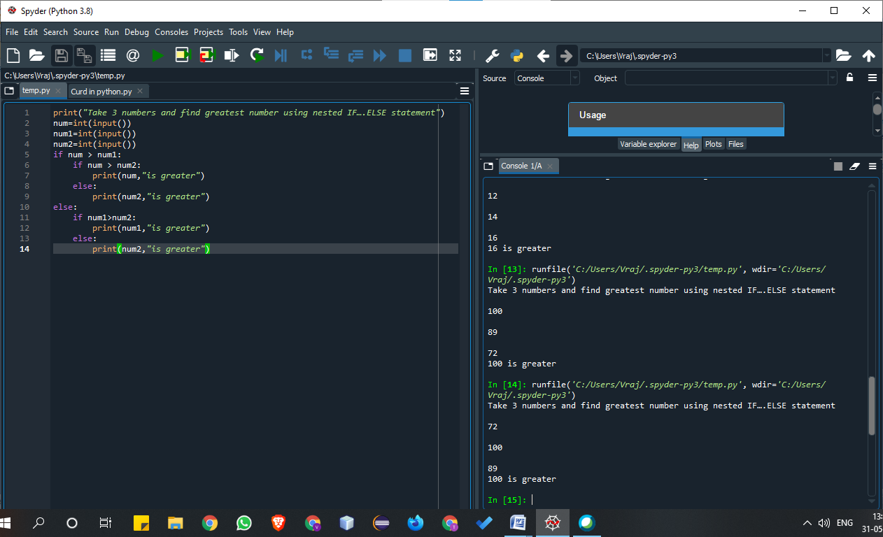

13. Take 3 numbers and find smallest number using logical operator.

Print(“Take 3 numbers and find smallest number using logical operator.”)

num=int(input())

num1=int(input())

num2=int(input())

if num>num1 and num1>num2:

print(num2,”is smaller”)

elif num>num1 and num2>num1:  
 print(num1,”is smaller”)

elif num1>num and num>num2:

print(num2,”is smaller”)

else:

print(num, “is smaller”)

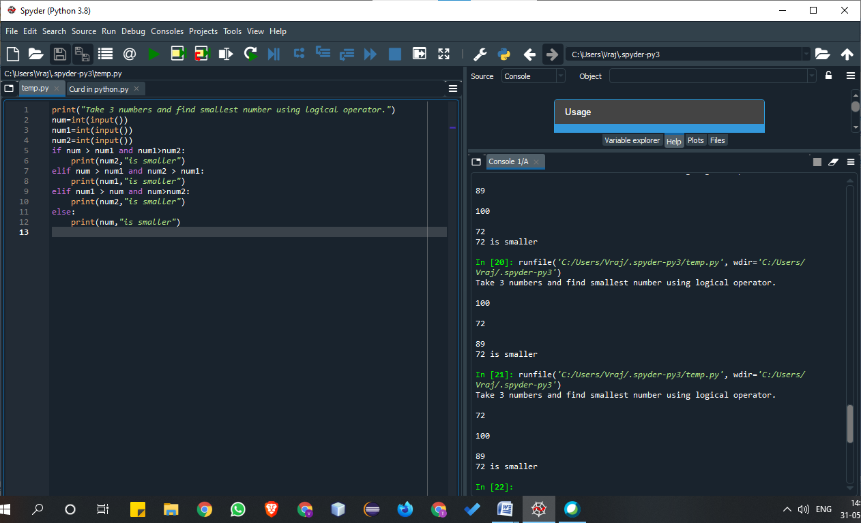

14. Write a program to swap 2 numbers without taking third variable.

print(“Write a program to swap 2 numbers without using third variable.”)

num=int(input())

num1=int(input())

print(“Before Swaping…….”)

print(“num=”,num)

print(“num1=”,num1)

print(“after Swapping….”)

num=num+num1

num1=num-num1

num=num-num1

print(“num=”,num)

print(“num1=”,num1)

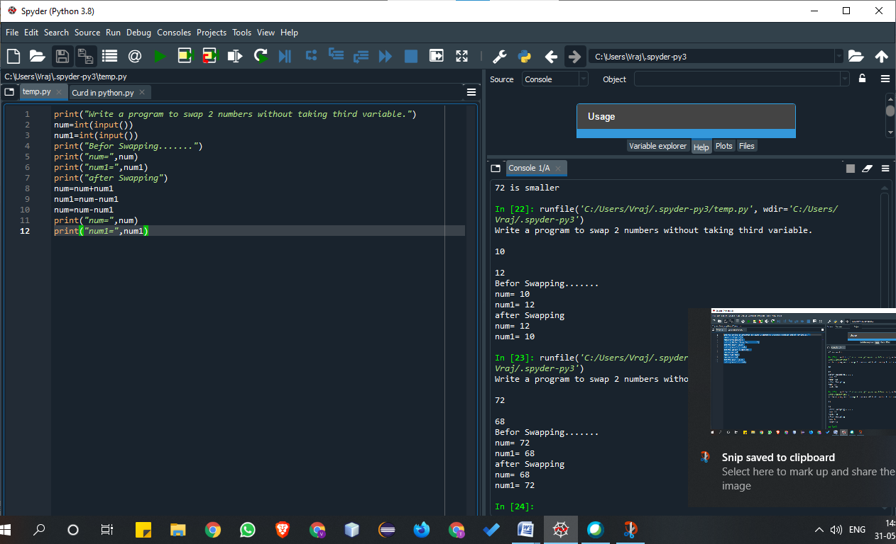

15. Write a program to swap 2 numbers without taking third variable.

print("Write a program to swap 2 numbers without taking third variable.")

num=int(input("Enter the starting the number=>"))

num1=int(input("Enter the ending the number=>"))

for i in range(num,num1,-3):

print(i)

